Remote working motivation and opportunities
Adel Shurab

Summary:

- Introduction
Remote work is a work system in which an employee does not have to travel to a workplace, such as a firm or an office, and the individual who works remotely is not bound to long-term contracts with a single entity or company. To bring individuals together regardless of their time or location.
At this time, remote work has become the company's goal in order to obtain talent from anywhere in the world at the lowest costs and to save the company money on equipment, furniture, and other items that employees require while in the company, all while increasing the company's productivity due to the employee's convenience.
According to a research, 70 percent of employees work remotely.

- Related work
telework : It is flexibility at work that allows the employee to perform his work in another place such as the home or any place equipped to work remotely. Remote work benefits the company and the employee in several ways, including enhancing the employment of a high-quality workforce and improving the employee’s morale as he can balance work and his life and facilitate the employee to accomplish tasks [1]

Effect Remote work makes employees happier and more productive than traditional employees and saves the effort of commuting to work daily. Saves money. According to a study from Harvard University in 2015, the performance of remote workers has improved dramatically because they feel that they have been freed from the shackles of the office[2]

Distance learning
what is distance learning ? It is a way to teach students online by sending lectures and educational materials to students while they are at home.
Thus, it becomes easier for the teacher to teach and take care of his home, and the student has more space and time to study
And the year 2017 was the first year in which students officially switched to distance education due to the Corona virus[3]

Electronic commerce is commerce through electronic media, where individuals and companies use websites and social media for trade or media
The most famous of them is online trading, which is done by buying shares of digital currencies or commodities for another. The first electronic trading platform was the American NASDAQ Stock Exchange.[4]

- Discussion and Analysis
We asked some employees about working remotely and how things were after the work shift
The response rates were 60% of men and 40% of women, and this is evidence of the lack of working women
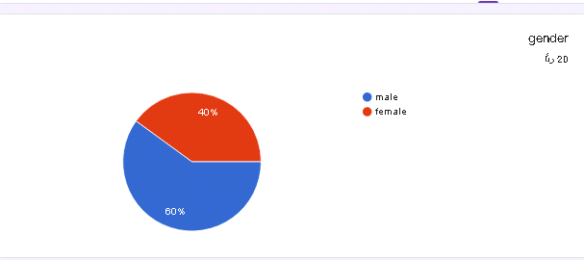
The highest percentage of employees was from the ages between 30-49, and there is also a percentage from the ages of 20-29, and this indicates that the company wants to benefit from
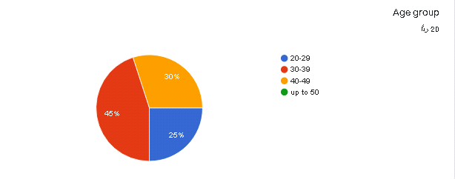

Here we see the experiences of the employees are the highest, where the experience of 5 to 10 years constitutes 55% of the employees and the experience of 10 to 15 constitutes 20% of the experience of less than five years
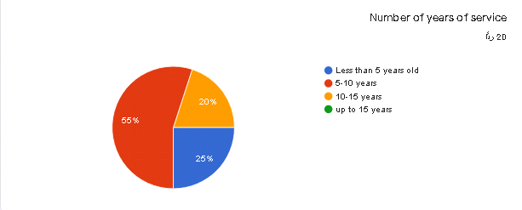
The percentage of employees who hold a bachelor’s degree is 85%, and the percentage of those who hold a diploma is 10%, and there is one person who holds a master’s degree, who is usually the manager
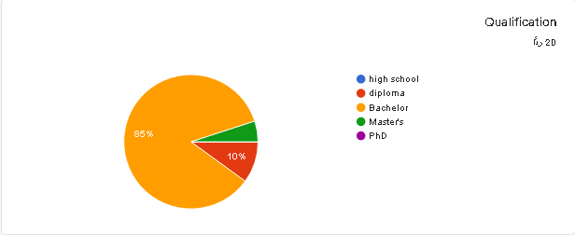
Here, it appears to us that employees prefer working remotely to provide them with comfort and space, as 70% of the employees preferred to work remotely and 30% of them said that working in the company is better.
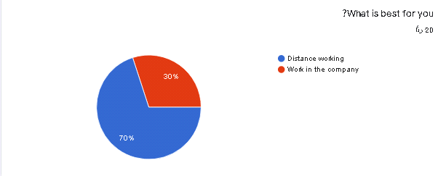
Here, we see that 75% of employees expect to increase opportunities in remote work because they say that it is better and helps to increase production and save companies and comfort for the employee, and 25% of them said that there is no increase in opportunities for those who want to work
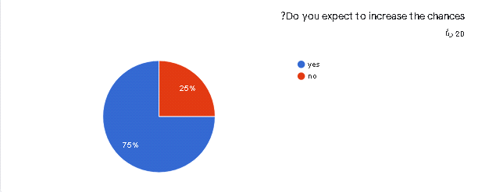

And 85% of the employees said that they were equipped to work remotely and trained to be more prepared and productive for the company, and 15% of them were not trained or directed
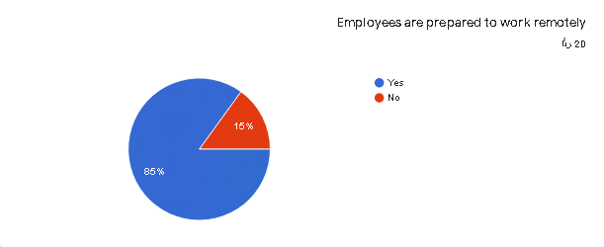

85% said that they do not employ women because they might be a burden on the company due to pregnancy and its responsibilities towards home matters and its disruption of work, and 15% of them said that there is no objection to hiring women
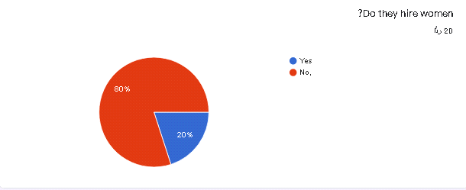
90% of the employees said that the productivity of the company has increased, and this indicates the success of remote work, due to the provision of comfort to the employee and giving him his own space, and thus he has a greater motivation for production, and 10% said that productivity has not increased due to lack of efficiency and lack of direction
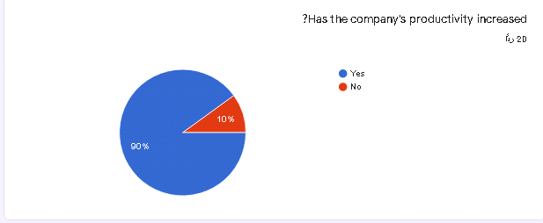
And the percentage of salaries was equal, where 50% of their salaries increased and 50% of their salaries decreased, and this does not mean that it is a bad thing
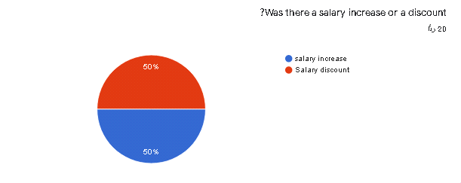
There are some international websites where I asked employees and published questionnaires about remote work, and one of the most famous of these sites is Pioneer, which specializes in managing online financial payments, released a statistic for the average income of the year for freelancers online. In this report, the company approved the collection of data through a comprehensive survey of 7000 employers and 150 countries.
70% of those surveyed are under the age of 35 and 21% of them are under the age of 25
Those younger than 35 have an hourly income between 16 and 19, while their peers older than 35 have an hourly income between 24 and 36.
74% of them use social media

- CONCLUSION
Telework was first proposed decades ago as a way to save time, money, and the environment. Millions of workers now telecommute every day, thanks to a slew of technical advancements that provide them more personal time while also allowing their employers to save money.

People used to have to sit in their cars for hours every morning on their way to their employer's office to make a living. The physical and emotional strain of commuting had an impact on a worker's productivity, job happiness, and overall well-being. People returned to their cars after a typical workday, lingered in traffic for a few more hours, and then drove home to relax and take care of personal duties and pleasures. That scenario is no longer valid.
Every day, telework removes millions of vehicles from the road, aiding in the slowing of environmental degradation. It also saves employees money on gas, wear & tear on their vehicles, and personal time. Employees who are less stressed and have more personal freedom are more productive and satisfied in their personal and professional lives.

Companies that accept telecommuters save a lot of money on facility costs, utilities, and regulatory compliance, making the employment model a win-win situation in many cases. Not everyone is suited to the new method of working. Some employees may be unable to telework due to their personal work habits and living circumstances.
Also, companies will realize they can hire telecommuters located anywhere in the world, helping them find workers with desirable skill sets. Companies might discover they can use telecommuting to acquire low-cost labor not available in their local labor pool. Finally, employees can expect to become happier, more productive, and personally fulfilled as they gain more time to spend with their favorite pastimes, family members, and friends.

Recommended
The workplace of the future must be a mix of employees working permanently or partially off-site and on-site employees working in more flexible shared environments In order to achieve success teleworking and teleworking programs must be coordinated with telecommuting and collaboration technologies that can support Program objectives and staff involved are equally important. Departments must plan the professional development and technical support programs needed to make effective use of these tools.
Work future

Among the work that can be done remotely is programming, trading, data filling, financing, buying and selling shares


References
- www.doi.gov. (2015). Telework & Remote Work. [online] Available at: https://www.doi.gov/telework.
- ResearchGate. (n.d.). (PDF) RATIONALIZING REMOTE WORKING CONCEPT AND ITS IMPLICATIONS ON EMPLOYEE PRODUCTIVITY. [online] Available at: https://www.researchgate.net/publication/ HYPERLINK "https://www.researchgate.net/publication/332171842_RATIONALIZING_REMOTE_WORKING_CONCEPT_AND_ITS_IMPLICATIONS_ON_EMPLOYEE_PRODUCTIVITY"332171842 HYPERLINK "https://www.researchgate.net/publication/332171842_RATIONALIZING_REMOTE_WORKING_CONCEPT_AND_ITS_IMPLICATIONS_ON_EMPLOYEE_PRODUCTIVITY"_RATIONALIZING_REMOTE_WORKING_CONCEPT_AND_ITS_IMPLICATIONS_ON_EMPLOYEE_PRODUCTIVITY.
- Simon, J. (2020). Distance Learning: The Complete Guide (2020). [online] Welcome to the TechSmith Blog. Available at: https://www.techsmith.com/blog/distance-learning/.
- Wikipedia. (2021). Electronic trading platform. [online] Available at: https://en.m.wikipedia.org/wiki/Electronic_trading_platform [Accessed 24 Dec. 2021].

